Phase 2: Create new Custom table

Navigation:

- Tables > Create New
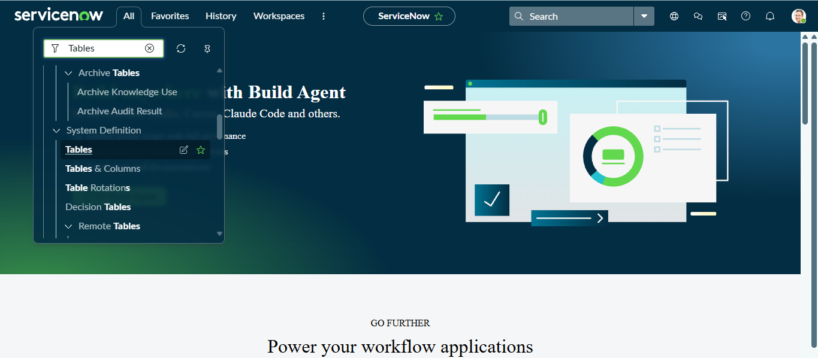
- Label: Employee Test
- Name: u_employee_test

- After creating and saving the Employee Test table, scroll down to the bottom of the table form.

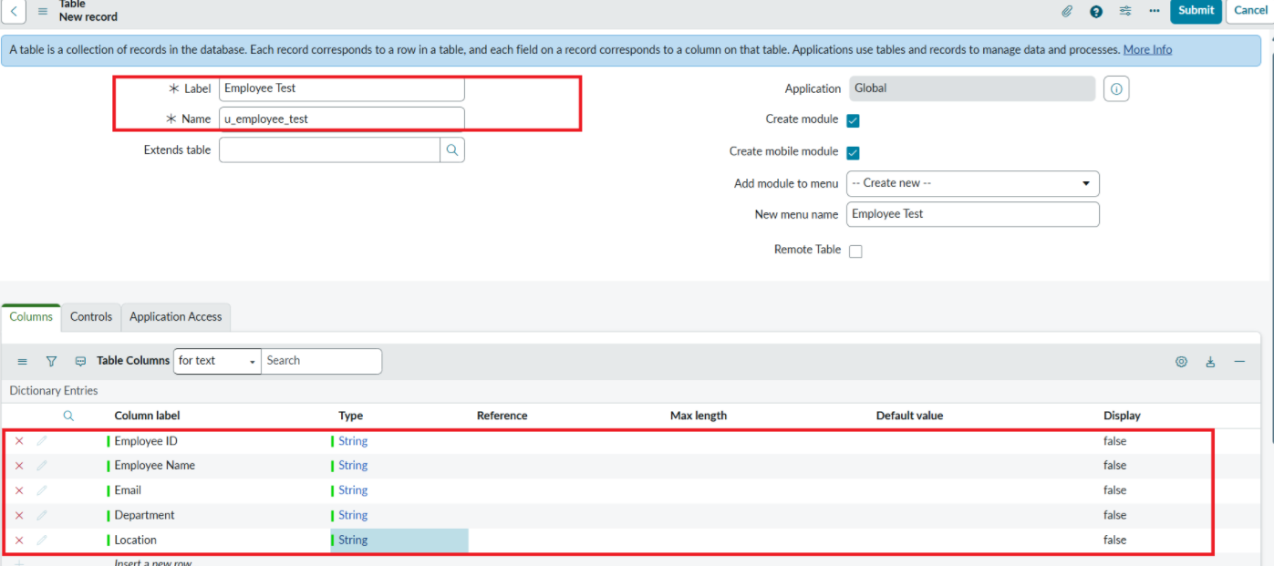
- Click Show Form to open the table form.

- On the form, locate the Form Context Menu / Additional Actions option on the left side of the form header.

- Click the Form Context Menu / Additional Actions icon.

- Click configure , select Form Layout.

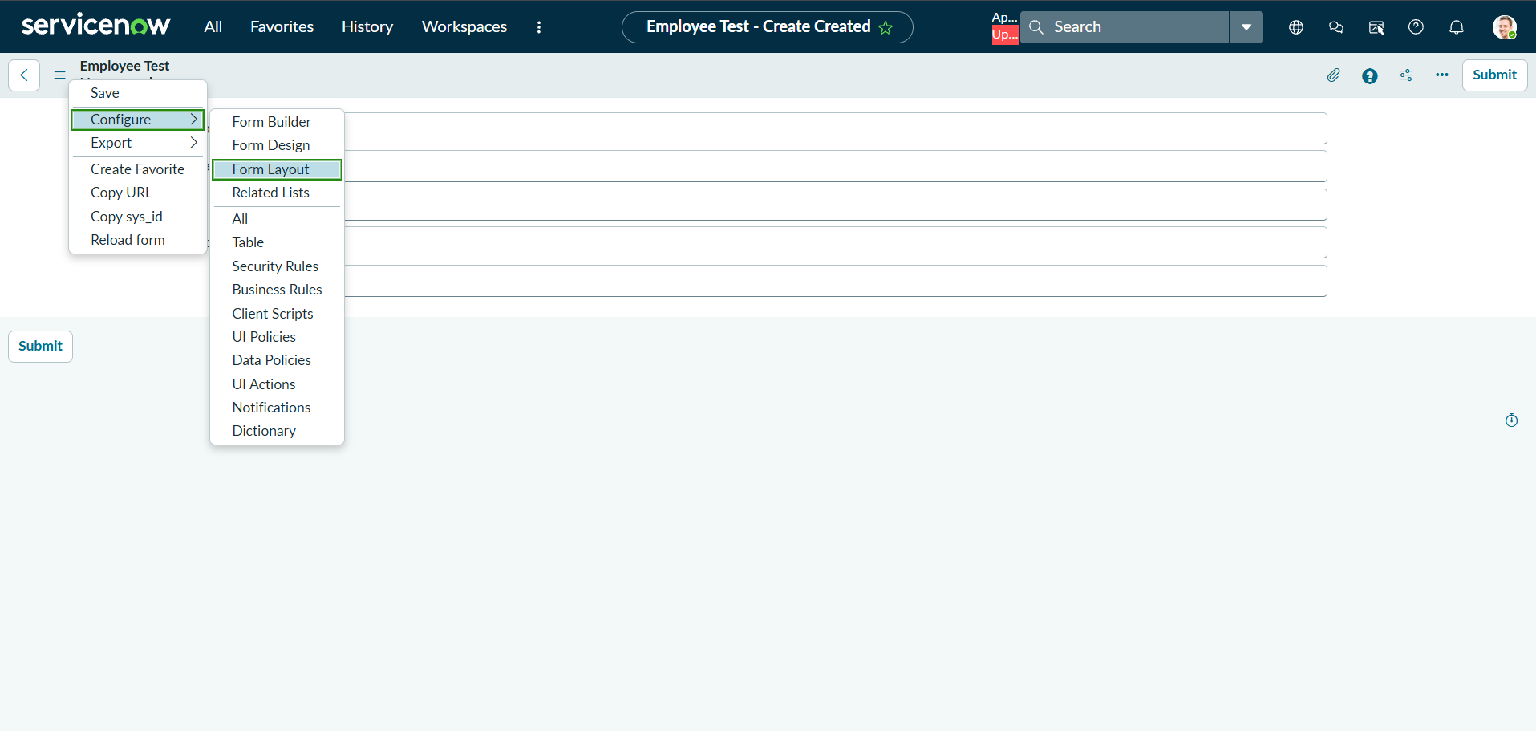

- The Form Layout page will open, where you can configure the fields displayed on the form

- After opening Form Layout, click New to create a new field.

- Enter the field details:
  - Column Label: Employee ID
  - Type: String
  - Click Add to create the field.

- Repeat the same steps to create the following fields:
  - Employee Name – Type: String
  - Email – Type: String
  - Department – Type: String
  - Location – Type: String

- After creating all the required fields, click Save.

- Verify that the newly created fields are displayed on the Employee Test form.

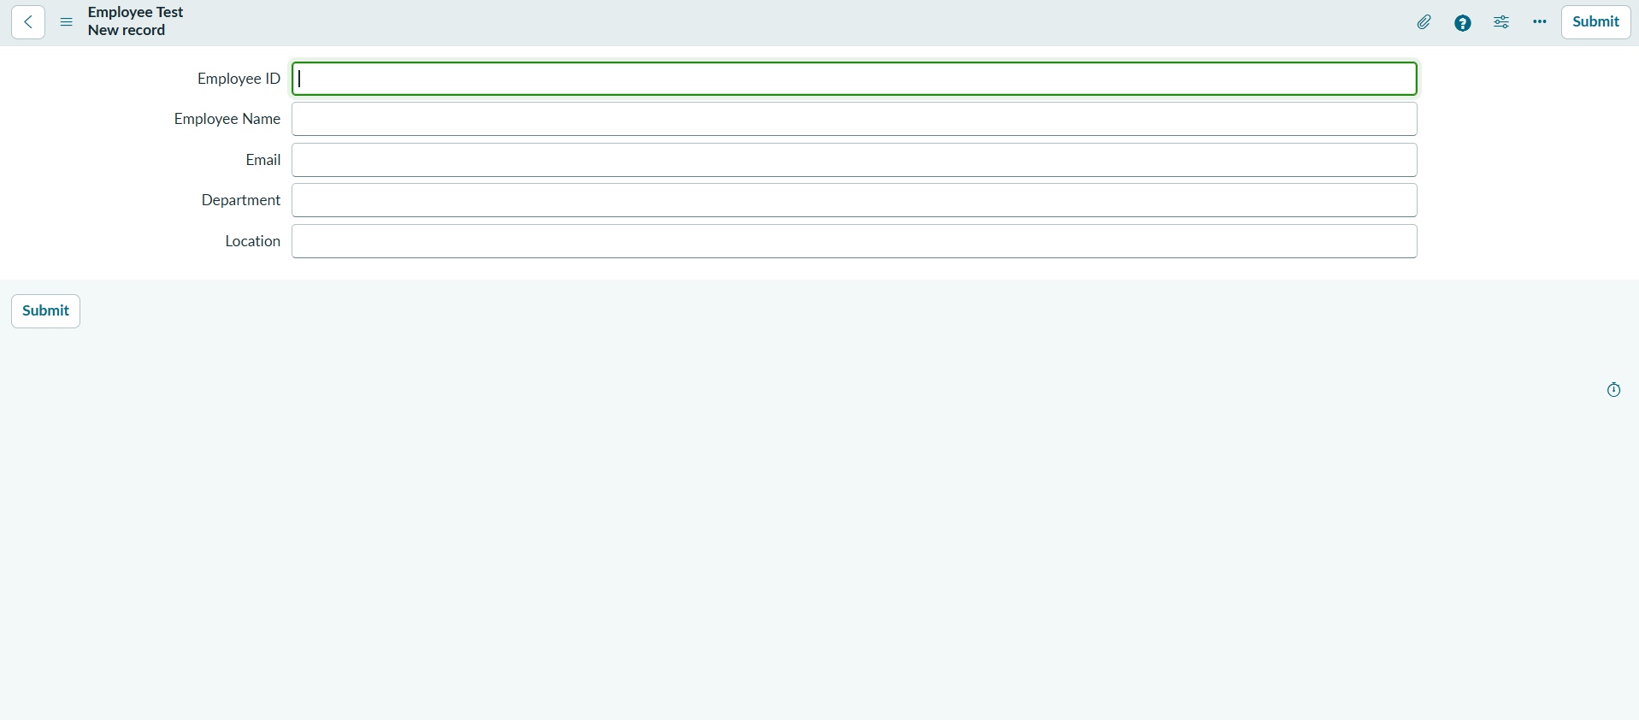

- Click on Submit or Save.

